

# Objective

You will

configure a Linux server as a NAT router for an internal network; reconfigure the DNS server for the new network;

enable port forwarding on the host machine.

1. **Setup an internal network**

Before you start any VMs, you will connect your server and desktop VMs to an internal network. Select the server from the left pane of the VirtualBox Manager and click the **Network** link on the

**Details** pane.

Enable **Adapter 2** and attach it to **Internal Network**; change the **Name** to intnet1.

Then select desktop from the left pane of the VirtualBox Manger and click the **Network** link on the

**Details** pane.

Change the **Adapter 1** to attach to **Internal Network**; change the **Name** to intnet1.

Now the network is set up as depicted in the following diagram.

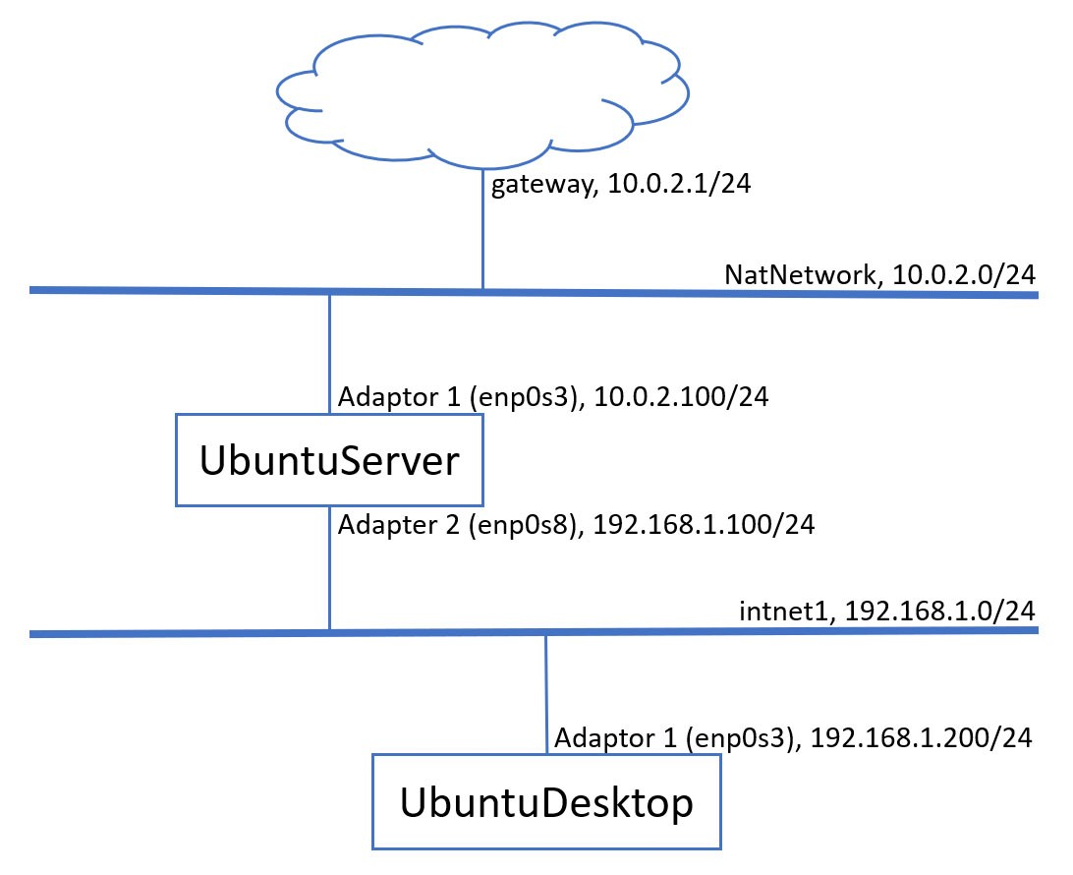

1. **Configure the network adapters**

You will set up static IP addresses for the Adapter 2 of the server VM and the Adapter 1 of the desktop VM according to the above network diagram. What will be the gateway for the desktop VM? 192.168.1.100

You will still use 10.0.2.100 as the DNS server.

You can use the ip link command to find out the adapter interface names. They may be different from the names indicated on the above diagram.

Do not forget using the netplan command to apply the new network configurations. In some cases, you may need to restart your VMs.

Once you finish configuring the adapters, you can ping to each other VMs using their IP addresses to verify the configurations.

If your VMs can ping each other, you can try to ping [www.baidu.com](http://www.baidu.com/) from both server and desktop VMs. Can you explain the results?

If you can ping from both VMs, you can proceed to the next task, otherwise fix the issues.

1. **Configure the server as a NAT router for the internal network**

You will configure the server VM as a NAT router for the internal network.

The server VM gets the Internet on the other end of the Adapter 1 (enp0s3) through the default gateway (10.0.2.1). You will configure it as a gateway for the internal network (intnet1) to allow the desktop VM which connected to the internal network to access Internet through it. On the server, do the following.

sudo su

echo 1 > /proc/sys/net/ipv4/ip_forward

iptables -t nat -A POSTROUTING -o enp0s3 -j MASQUERADE exit

These commands enable the packet forwarding in the server to work as a router and add the rules for the iptables. The rule in POSTROUTING chain in the NAT table indicates that the interface enp0s3 should be used for outgoing packets and MASQUERADE indicates that the interface will mask the internal IP address (192.168.1.0/24) with the external IP address (10.0.2.100) of the router.

Now you should able to ping [www.baidu.com](http://www.baidu.com/) from the desktop VM.

To make the packet forwarding persistent across boots, edit /etc/sysctl.conf on the server and make sure the net.ipv4.ip_forward variable is set to true as follows:

net.ipv4.ip_forward = 1

To make the iptables rules persistent across boots, you need install a package and save the rules for boot.

sudo apt install iptables-persistent

If you does not save the rules while install the package, you need to save current rules.

sudo netfilter-persistent save

The netfilter-persistent package has been installed along with the iptables-persistent

package.

1. **Reconfigure the DNS server**

You will reconfigure the DNS for the new hosts on the internal network. If your DNS still not working properly, this is the chance to make it work.

You will need to modify the forward zone file to change the IP address for the desktop VM. You will also modify the reverse zone file to remove the old entry for the desktop VM and create a new reverse zone file for the internal network 192.168.1.0/24. You will need to modify the named.conf.local file to include the new reverse zone.

您需要修改转发区域文件以更改桌面VM的IP地址。您还将修改反向区域文件以删除桌面VM的旧条目，并为内部网络192.168.1.0/24创建新的反向区域文件。您需要修改named.conf.local文件以包含新的反向区域。

sudo pico /etc/bind/named.conf.local

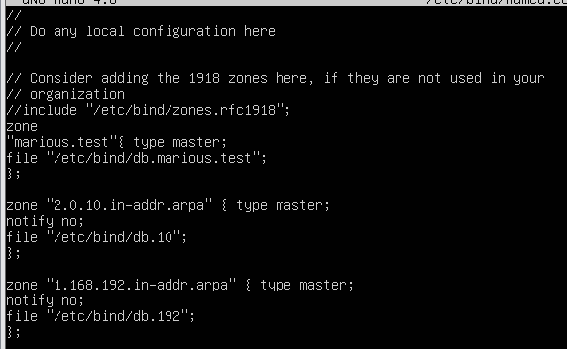

sudo pico /etc/bind/db.marious.test

;

; BIND data file for local loopback interface

;

$TTL 604800

@ IN SOA server.marious.test. asl.seu.edu.cn.(

2019112001 ; Serial

604800 ; Refresh

86400 ; Retry

2419200 ; Expire

604800 ) ; Negative Cache TTL

;

@ IN NS server.marious.test.

@ IN A 127.0.0.1

@ IN AAAA ::1

gateway IN A 10.0.2.1

server IN A 10.0.2.100

desktop IN A 10.0.2.200

dns IN CNAME server

www IN CNAME server

不确定是哪个

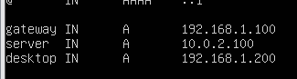

sudo cp /etc/bind/db.10 /etc/bind/db.192

pico他

;

; BIND reverse data file for local loopback interface

;

$TTL 604800

@ IN SOA server.marious.test. asl.seu.edu.cn. (

2019112001 ; Serial

604800 ; Refresh

86400 ; Retry

2419200 ; Expire

604800 ) ; Negative Cache TTL

;

@ IN NS server.marious.test.

1 IN PTR geteway.marious.test.

100 IN PTR server.marious.test.

200 IN PTR desktop.marious.test.

Do not forget restart the bind9 service;

You should check the DNS configuration for errors; (How ?)

named-checkconf 不报错

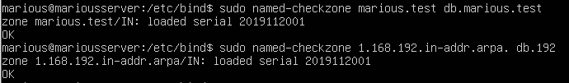

You may need to clear the local DNS cache using the command sudo systemd-resolve

--flush-caches.

再重启一下

Now you can ping each other VMs using their host names. Test the reverse zone as well.

1. **Enable port forwarding on the host machine**

You will configure the NAT Network on the host machine to allow port forwarding that enables the host machine to access your web server on the server VM.

On the VirtualBox Manager, select the Preferences from the File menu. Then select the Network and the configuration icon with a gear. Press the Port Forwarding button then add Rule 1. Set the values as follows.

Protocol: TCP Host IP: 0.0.0.0

Host Port: 80

Guest IP: 10.0.2.100

Guest Port: 80

This will forward the request on port 80 on the host machine to the port 80 on the virtual guest machine.

Let's disable the name based virtual host of the Apache server on the server VM.

sudo a2dissite racktables sudo systemctl reload apache2

From your host machine (the physical machine, not virtual machines), open a browser to point to

[http://localhost/dokuwiki.](http://localhost/dokuwiki) You should see your Dokuwiki home page.

# Submission and mark

Show your work to the teacher. Of 6 marks, you can get

1.5 for demonstrating that the internal network is working by pinging each other VMs using their IP addresses (Task 2);

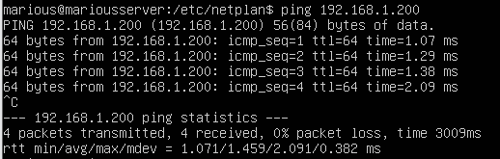

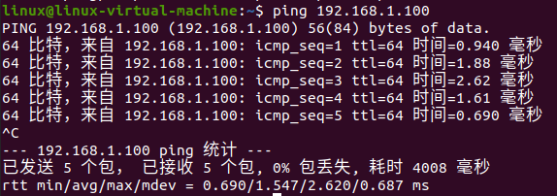

1.5 for demonstrating that the NAT router is working by pinging [www.baidu.com](http://www.baidu.com/) from the desktop VM (Task 3);

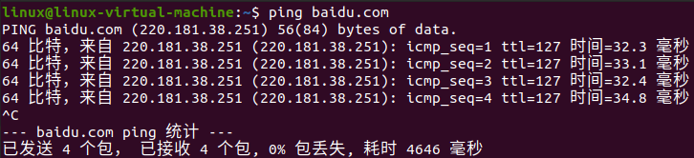

1.5 for demonstrating that the DNS is working by pinging each other VMs using their host names (Task 4);

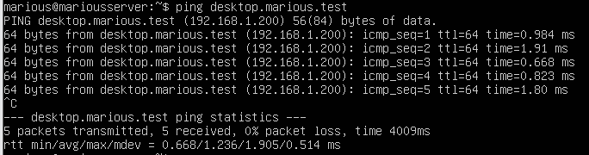

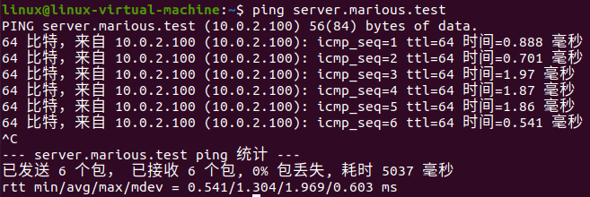

1.5 for demonstrating that the port forwarding is working by accessing the Dokuwiki from the host machine (Task 5).

You should be ready to answer any questions to demonstrate that all work is done by yourself otherwise you may receive 0 mark.

IMPORTANT NOTE: You will need to document all of your lab work in your wiki.